**[Check out the lead single, “You Got Me”.](https://www.youtube.com/watch?v=Qk_bXPkPOHs)**

[**Click here to listen to “Love’s Not”.**](https://soundcloud.com/conya-doss/love-not-mix-1/s-ZfaRl)

**here.**

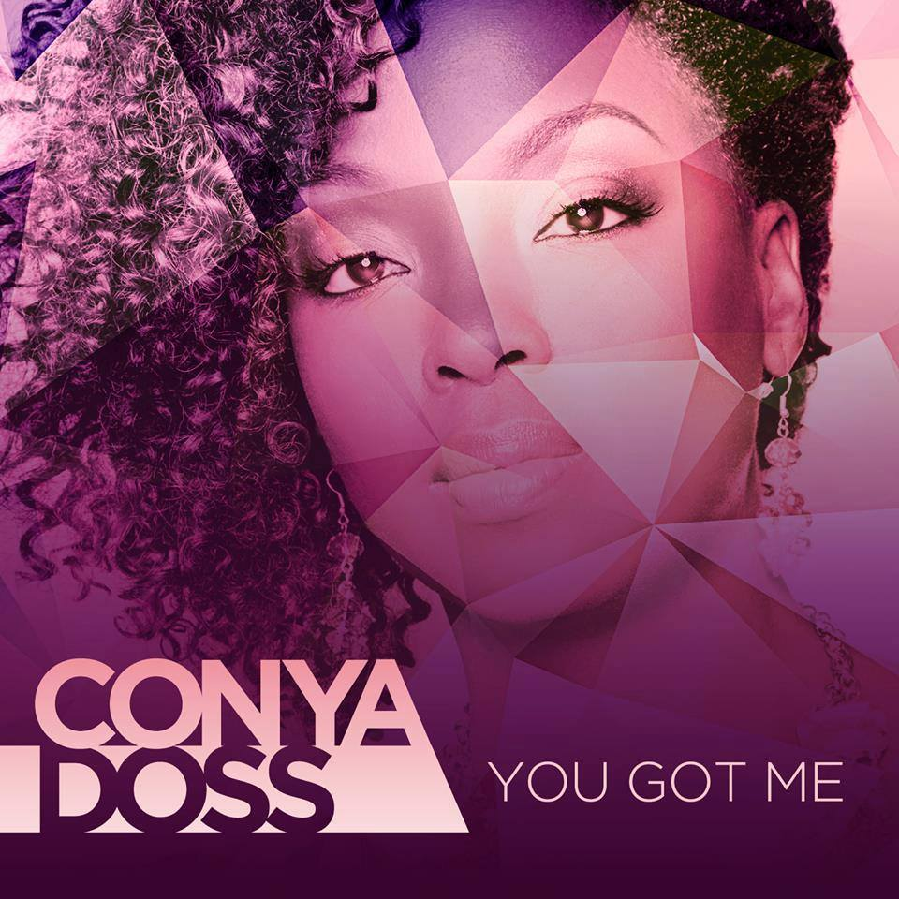

[**Click here to listen.**](https://soundcloud.com/conya-doss/when-we-love-mix/s-7MjxC)

**Pre-order will be available soon!!**

New Singles “When We Love ” and “Love’s Not” from

Multi-Award Winning Singer/Songwriter Conya Doss’

upcoming album VII (Seven).

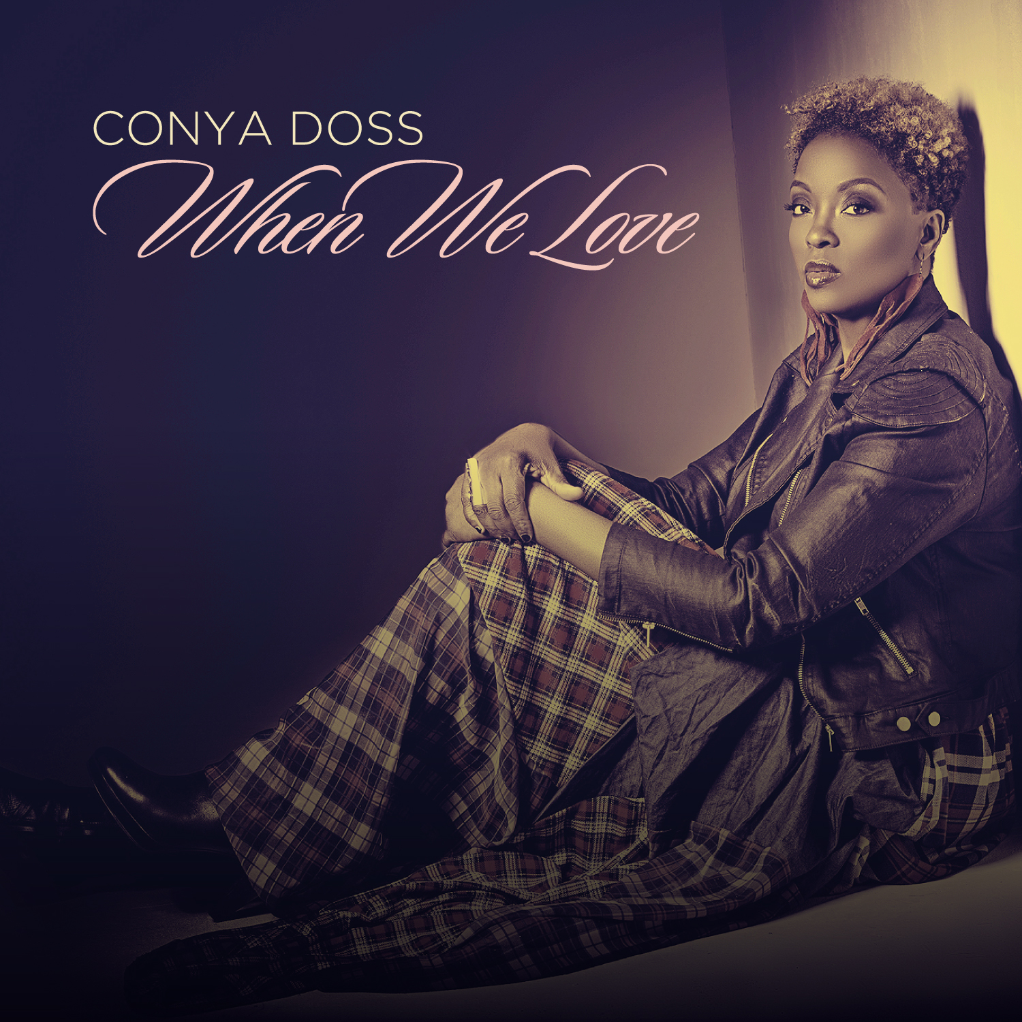

Conya Doss heeds the spiritual nudges of her heart and pens an emotionally resonant 7th studio album set for an May 19, 2015 release.  **E:\Life\Da stuff\CENTON USB\CYT\Clients - prospects\Archived\Conya Doss\Pictures\2015\ll.jpg**





